Day 2 - 104608492 - Shirisha Perapagu

Git commands

init

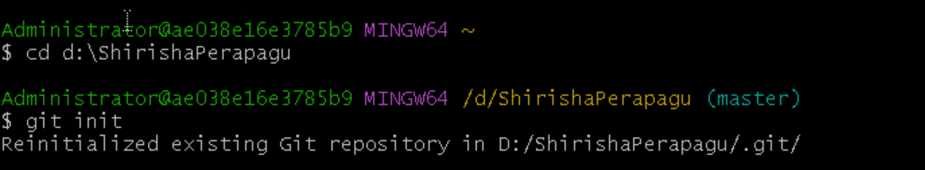

 Add and commit

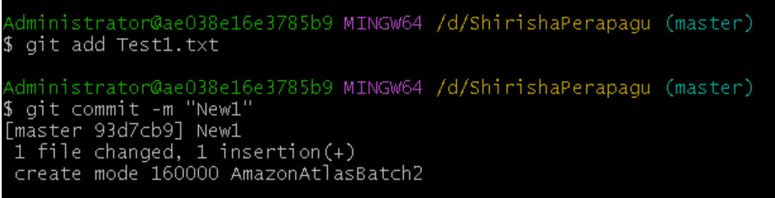

Log

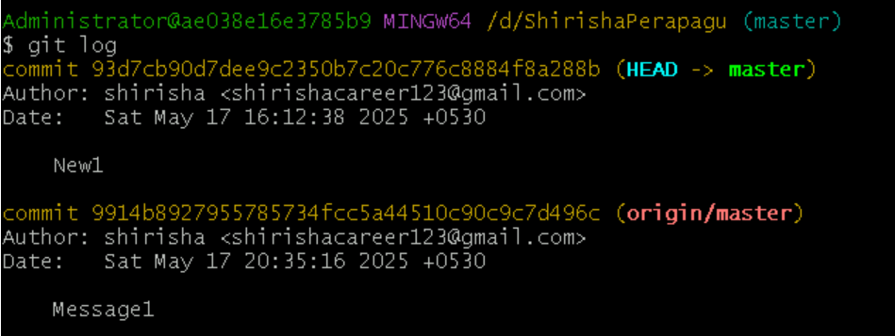

Show

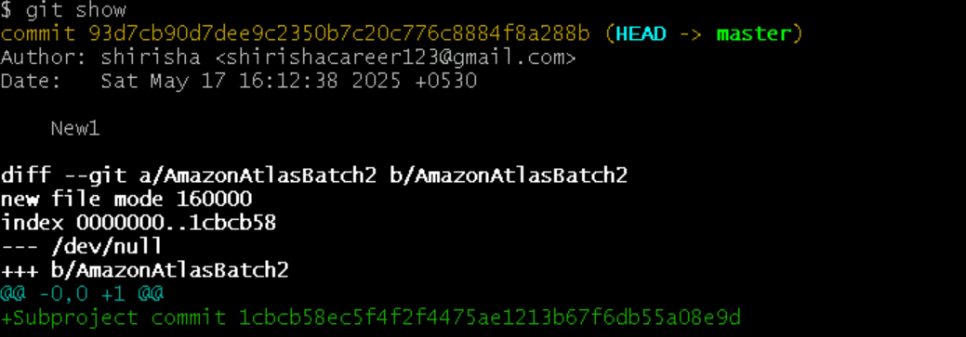

All Branches and new Branch named FirstBranch

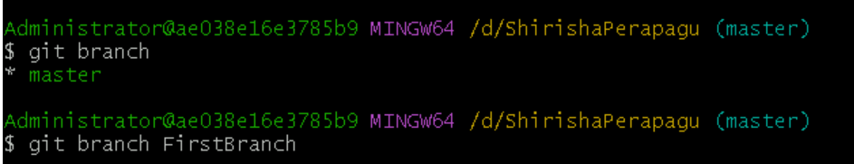

All branches now and checkout Branch

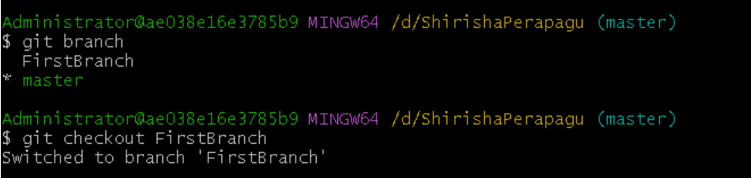

Merging FirstBranch and Master

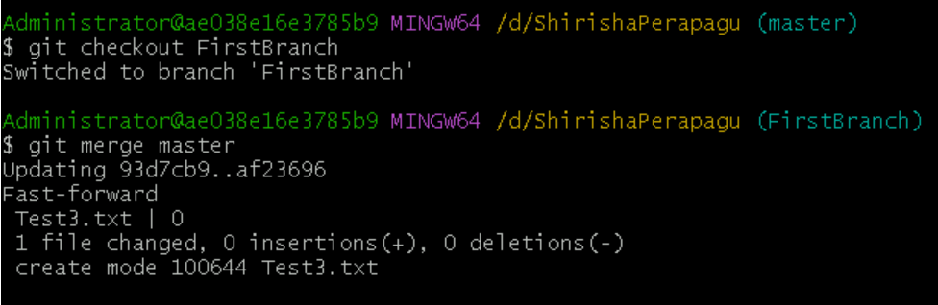

stash

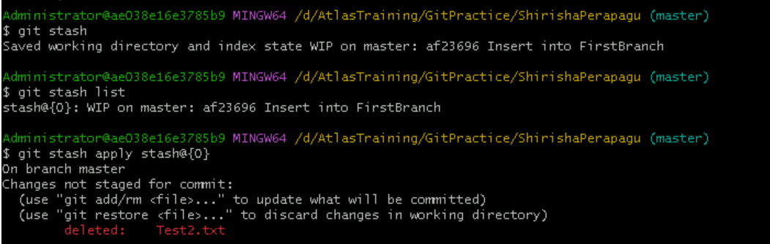

reset



Revert

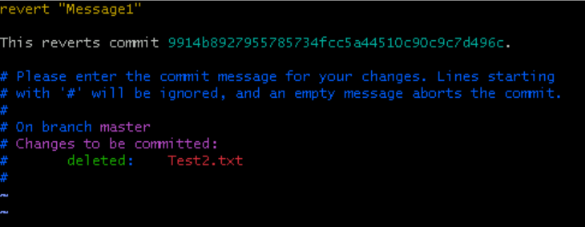

Tag



List of all tags



Specific tag

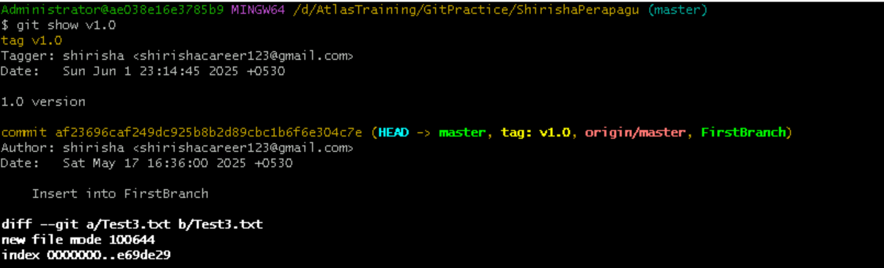

Delete a tag

